Fine City Blues Festival 2017 October 19th – November 9th

The Fine City Blues Festival goes into its fourth year with concerts in Norwich, Norfolk and beyond. The Fine City Blues Festival focuses on real Blues and real Blues Roots music and this year features an amazing line-up in intimate venues where the Blues can be heard at its best.

This year’s artists include the following:

Egypt “… the loudest, yet most wonderful Blues-Rock band …” Leicester Mercury
Travis “Moonchild” Haddix returns to play a series of concerts with the Dave Thomas Band in Norwich, Blakeney, Burston and in Castor (Nr. Peterborough). Travis has received rave reviews and toured all over the USA and Europe since 1992. His style evokes the sounds of the great Stax-Volt days, when the likes of Sam & Dave ruled the urban Blues roost. British Blues band leader Dave Thomas has worked with many American Blues artists in the USA and in Europe. “… a fine guitarist” Paul Jones, The Blues Band/Manfred Mann/BBC Radio 2.

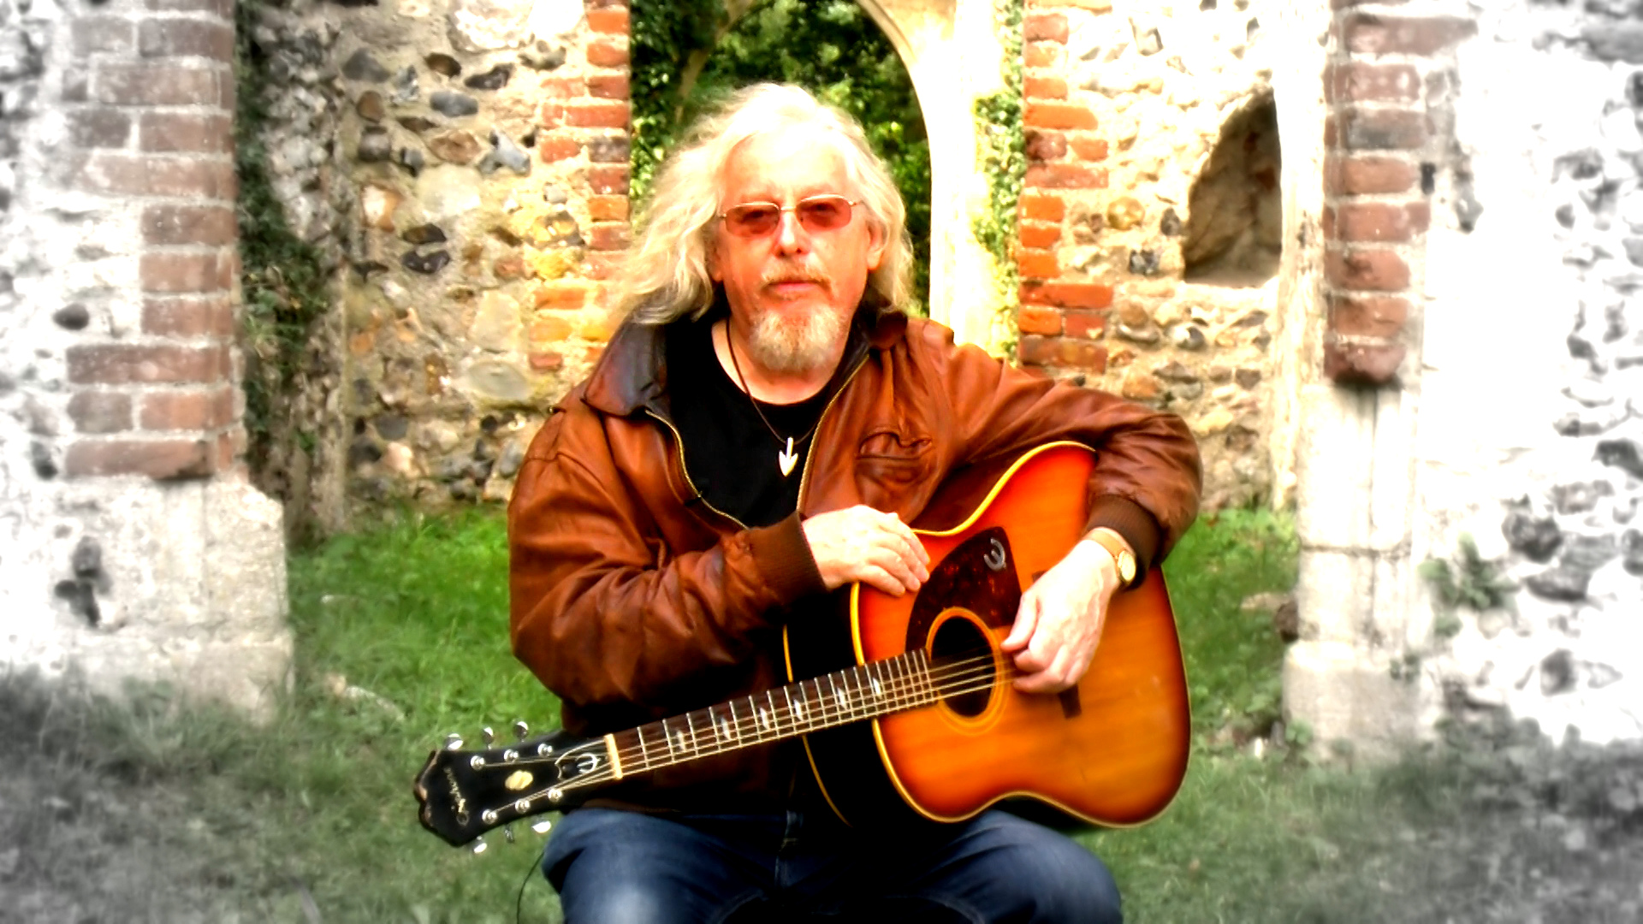
Norwich and Norfolk will be alive with Blues from 19th October through into November. Other great artists appearing are John Mayall “The Godfather of British Blues!” who plays the Theatre Royal in Norwich on Wednesday 25th October; rising singer-songwriter Sean Taylor “… a wonderfully talented modern troubadour…” Eric Bibb; Kat Pearson “… smoky, sassy and very classy” Blues Matters Magazine; Paul Lamb & Chad Strenz “…Blues harp as good as it gets” Mark Knopfler; and great American acoustic troubadour Doug MacLeod who is now at the top of his game. There are more great artists performing at Fine City Blues Festival including some exceptionally talented locally based musicians such as the Dove & Boweevil Band.

The Festival is being organised by Fine City Blues, a working partnership between Steve Morphew, presenter of Best of the Blues on Future Radio and Dave Thomas (pictured above) who has lived and worked in East Anglia for many years. For further information and the latest festival news, please visit https://www.facebook.com/pages/Fine-City-Blues/806008389432604

Direct festival contact Dave Thomas dave1968thomas@gmail.com

For all media enquiries, please contact James Soars.
james@jameshsoars.com Tel 01536 720245/07758 781032

